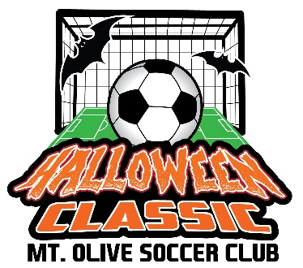
Coaches and Team Managers – October 21st Teams Only,
Welcome to the 30th Annual Mount Olive Halloween Classic Tournament. All teams must check in electronically this year. In order to have enough time to review and approve submissions, all electronic check-ins must be submitted prior to Wednesday, October 18th at 9:00 p.m.

Electronic Check-in Instructions
The following information is required to check in.
- Team Information Form: Complete the form below.
- USYSA or US Club Approved Roster: A copy of your official team roster. Write in any guest player’s name and date of birth.
- Coach / Player Cards: A copy of each coach and player card. Guest player’s primary card should be copied and included as well.
The information mentioned above must be provided in a single PDF file, in the order listed above. For example, the completed Team Information Form should be the first page in the PDF, the team roster should be the second page, etc. If you are unsure of how to create a PDF file, you can either cut and paste your information into PowerPoint or Word and then save as a PDF, or you can use a website like www.pdfcombine.com to help you combine the information into a single PDF file.
The single PDF file must be emailed to checkin@mountolivesoccer.com before 9:00 p.m. on Wednesday, October 18th. The subject line of your email must include your club name, team name, age group, and gender. For example, Mount Olive Soccer Club – Thunder – U11 – Boys. Once your team documentation has been validated, you will receive an email indicating your check-in was approved. You are required to have all of your original documents (roster, player cards, medical forms, and guest player information) with you on Saturday, as you may be asked to provide the documents if any issues or questions arise. Upon arrival on Saturday, go to the main tent at Turkey Brook Park to receive your coach’s bag (e.g., tournament patches, MVP cards, etc.).
Team Information Form
Team Name
Team Age
Team Gender
Contact Name
Contact Cell Phone
Contact Email
Comments

